**PORTFOLIO PROJECT**

Submitted by

**KAVINPRASATH S M**

**Reg. No: 1P24CS011**

In partial fulfilment of the requirement for the award of the Degree of

### Master of Science in Computer Science

### Bharathiar University, Coimbatore.

Under the Internal Supervision of

# Dr. P. V. Ravindranath M.Sc., Ph.D.,

**Assistant Professor**

**School of Computer Studies-PG**



### School of Computer Studies-PG,

**Rathnavel Subramaniam College of Arts and Science (Autonomous),**

### Sulur, Coimbatore – 641 402

**October- 2024**

### RATHNAVEL SUBRAMANIAM COLLEGE OF ARTS AND SCIENCE (AUTONOMOUS)

**AFFILIATED TO BHARATHIAR UNIVERSITY**

**NAAC Re-accredited & ISO 9000:2008 Certified SULUR, COIMBATORE-641402.**

**Master of Science in Computer Science**



**October 2024**

**Register Number – 1P24CS011**

Certified bonafide original record of work done by **KAVINPRASATH S M**

Submitted for the project Evaluation and Viva voice held on**………………….**

### Internal Supervisor HOD

### Internal Examiner External Examiner

# 

# Certificates

# Certificate

This is to certify that the project work entitled **PORTFOLIO**, submitted to the School of Computer Studies(PG), Rathnavel Subramaniam College of Arts and Science in partial fulfillment of the requirements for the award of the Degree of Master of Science in Computer Science is a record of original project work done by **KAVINPRASATH S M** during the period July 2024- October 2024 of her study in the **Master of Science in Computer Science, Rathnavel Subramaniam College of Arts and Science**, under my internal supervision and the project work has not formed the basis for the award of any Degree/Diploma/Associateship/Fellowship or other similar title to any candidate of any University.

Internal Supervisor

# 

# Declaration

## **Declaration**

I, **KAVINPRASATH S M**, hereby declare that the project work, entitled **PORTFOLIO**, submitted to the School of Computer Studies(PG), Rathnavel Subramaniam College of Arts and Science, in partial fulfillment of the requirements for the award of the Degree of Master of Science in Computer Science is a record of original project work done by me during the period July 2024–October 2024 under the internal supervision of **Dr.P.V.Ravindranath, M.Sc. CS, Ph.D.,** Assistant Professor, School of Computer Studies, Rathnavel Subramaniam College of Arts and Science, and it has not formed the basis for the award of any Degree/ Diploma/Associateship/Fellowship or other similar title to any candidate of any University.

# Signature of the Candidate

# 

Acknowledgement

## **Acknowledgement**

If words are considered as symbols of approval and tokens of acknowledgement, then the

words play the heralding role of expressing my gratitude to all who have helped me directly or indirectly during my project work.

I will be ever graceful and thankful to **Dr. T. Sivakumar, M.Sc., M.Phil., Ph.D., Principal**, Rathnavel Subramaniam College of Arts and Science for allowing me to do my project with his moral support.

It gives me immense pleasure to take this opportunity to express my gratitude and thanks **Dr. P. Navaneetham, M.Sc., M.Phil., Ph.D., Associate Professor & Director Administration, School of Computer Studies**, Rathnavel Subramaniam College of Arts and Science for his continuous encouragement and blessings. First and foremost, my utmost gratitude to **Dr.S.Yamini, M.Sc., M.Phil., Ph.D., Associate Professor & Director Academics, School of Computer Studies**, Rathnavel Subramaniam College of Arts and Science for her ardent support and noble patronage.

I proudly feel graceful to **Dr.D.Maheswari, M.Sc., M.Phil., Ph.D**., **Associate Professor, Head & Research Coordinator, M.Sc. Computer Science, School of Computer Studies(PG),** Rathnavel Subramaniam College of Arts and Science for providing me this opportunity and extending a constant monitoring throughout the course of the project.

With my gratitude I would like to acknowledge the immense encouragement given to me

by **Dr. P.V.Ravindranath, M.Sc. CS., Ph.D., Assistant Professor, School of Computer Studies (PG),** Rathnavel Subramaniam College of Arts and Science who is my internal guide, for her valid suggestions, and counsel, and ever willing to extend help. I am deeply obliged to his for the encouragement and without him the project work would not have been successful.

**KAVINPRASATH S M**

**PORTFOLIO PROJECT**

# 

# Abstract

## **Abstract**

An abstract of a portfolio typically provides a concise overview of the contents and key highlights of the portfolio. It serves as a summary that offers a glimpse into the scope and purpose of the portfolio. The abstract may include a brief description of the portfolio's main objectives, the types of assets or projects included, the methodologies used, and the overall outcomes or achievements. Additionally, it might highlight the significance of the portfolio in relation to the broader context or industry, showcasing the relevance and impact of the work. The abstract aims to capture the essence of the portfolio, enabling readers to quickly grasp its essence and potential significance

# 

# Content

**CONTENT**

# PORTFOLIO PROJECT

Chapter 1: 1

Video Introduction

1.1. YouTube Video

Chapter 2: 2

Website Bio Score

* 1. Minimum 50 words (Include photo)
  2. Contact Information (LinkedIn, GitHub, Email, Etc.)

# Chapter 3: 8

Pages & Navigation

* 1. Landing Page

3.2. Project Page

3.3. Navigation Bar

# Chapter 4: 19

Styles Score

* 1. Styles (Font Color Images)
  2. Styles Link (Link in Blue color & Underline Navigation)
  3. Use of Grid Layout

# Chapter 5: 24

Website Include the Following Information

* 1. Project Links to GitHub
  2. Project Description (1-5 sentences per projects)

# Chapter 6: 26

Bootstrap

6.1. Uses Bootstrap

# Chapter 7: 27

Project README

* 1. Title Description (Min 20 words)
  2. How to Run Project
  3. Future improvements of projects

# Chapter 8: 29

File Structure

8.1. GitHub File Structure

PORTFOLIO PROJECT

# CHAPTER 1

## **VIDEO INTRODUCTION**

**1.1 YouTube Video Introduction**

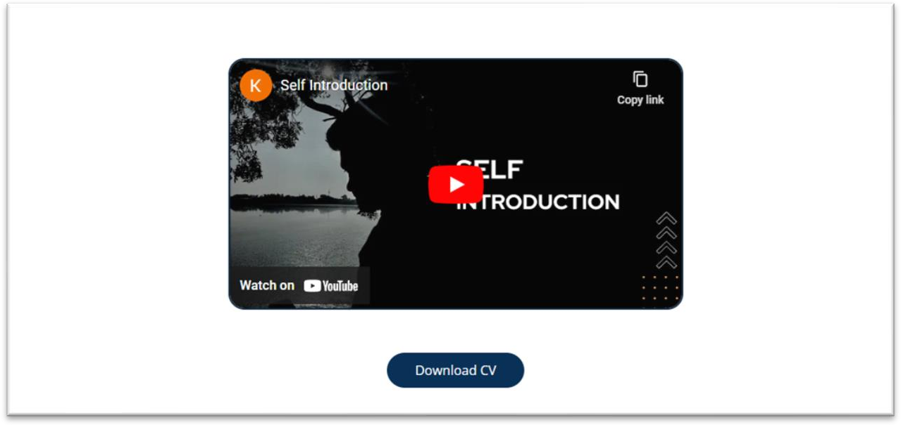

**CHAPTER 2**

**WEBSITE BIO SCORE**

**2.1About me**

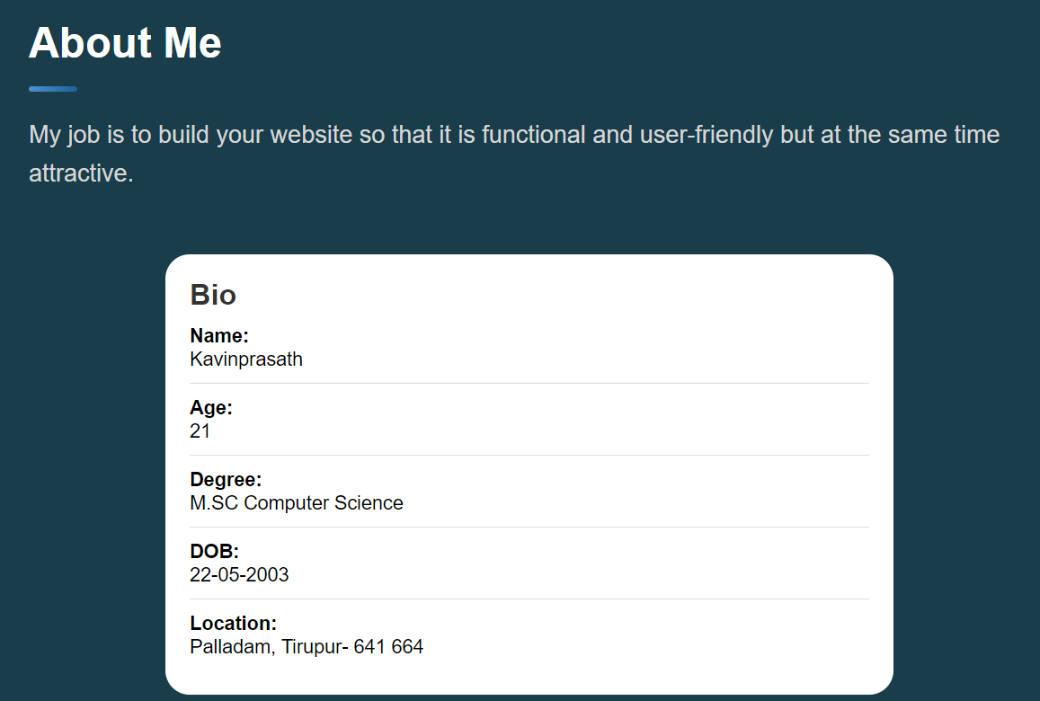

Figure- 2.1.1

**Description:**

In this page, there is an Image of mine, paragraph about me. So that the details of my biodata have been given.

## **Source code:**

**HTML:**

<header>

          <h2 class="h2 article-title" id="about">About me</h2>

        </header>

        <section class="about-text">

          <p style="font-size: 20px;">

            My job is to build your website so that it is functional and user-friendly but at the same time attractive.

          </p>

        </section>

        <div class="bio-container">

          <h1>Bio</h1>

          <ul>

              <li><span class="bio-title">Name:</span> Kavinprasath</li>

              <li><span class="bio-title">Age:</span> 21</li>

              <li><span class="bio-title">Degree:</span> M.SC Computer Science</li>

              <li><span class="bio-title">DOB:</span> 22-05-2003</li>

              <li><span class="bio-title">Location:</span>Palladam, Tirupur- 641 664</li>

          </ul>

        </div>

## **CSS:**

.about .article-title { margin-bottom: 15px; }

.about-text {

  color: var(--light-gray);

  font-size: 14px;

  line-height: 1.6;

}

.about-text p { margin-bottom: 15px; }

**2.2 Information**



Figure- 2.2.1

**Description:**

The above displayed figure is the resume page. To know about my education qualification resume will be helpful in knowing the qualifications easily.

**Source code:**

**HTML:**

<section style="padding-top: 80px;" id="education">

          <header >

            <h2 class="h2 article-title">Education</h2>

          </header>

          <section class="timeline">

            <div class="title-wrapper">

              <div class="icon-box">

                <ion-icon name="book-outline"></ion-icon>

              </div>

              <h3 class="h3" style="font-size: 25px;">Education</h3>

            </div>

            <ol class="timeline-list">

              <li class="timeline-item">

                <h4 class="h4 timeline-item-title">Bharathi Matric Hr.Sec.School,Palladam</h4>

                <span>2018-2020</span>

              </li>

              <li class="timeline-item">

                <h4 class="h4 timeline-item-title">Rathnavel Subramaniam College Of Arts And Science,Sulur</h4>

                <span>2020-2023</span>

                <p class="timeline-text">

                  B.SC Computer Science

                </p>

              </li>

              <li class="timeline-item">

                <h4 class="h4 timeline-item-title">Rathnavel Subramaniam College Of Arts And Science,Sulur</h4>

                <span>2024—2026</span>

                <p class="timeline-text">

                  M.SC Computer Science

                </p>

              </li>

            </ol>

          </section>

</section>

**CSS:**

article {

  background: rgba(18, 55, 69, 0.826);

  border: 8px groove rgba(18, 55, 69, 0.826);

  border-radius: 40px;

  padding: 5px;

  z-index: 1;

}

article { display: none; }

article.active {

  display: block;

  animation: fade 0.5s ease backwards;

}

.article-title {

  position: relative;

  padding-bottom: 7px;

  font-size: 35px;

}

.article-title::after {

  content: "";

  position: absolute;

  bottom: 0;

  left: 0;

  width: 30px;

  height: 3px;

  background: var(--text-gradient-yellow);

  border-radius: 3px;

}

**CONTACT INFORMATION**

**2.3. Contact Page and Download CV**

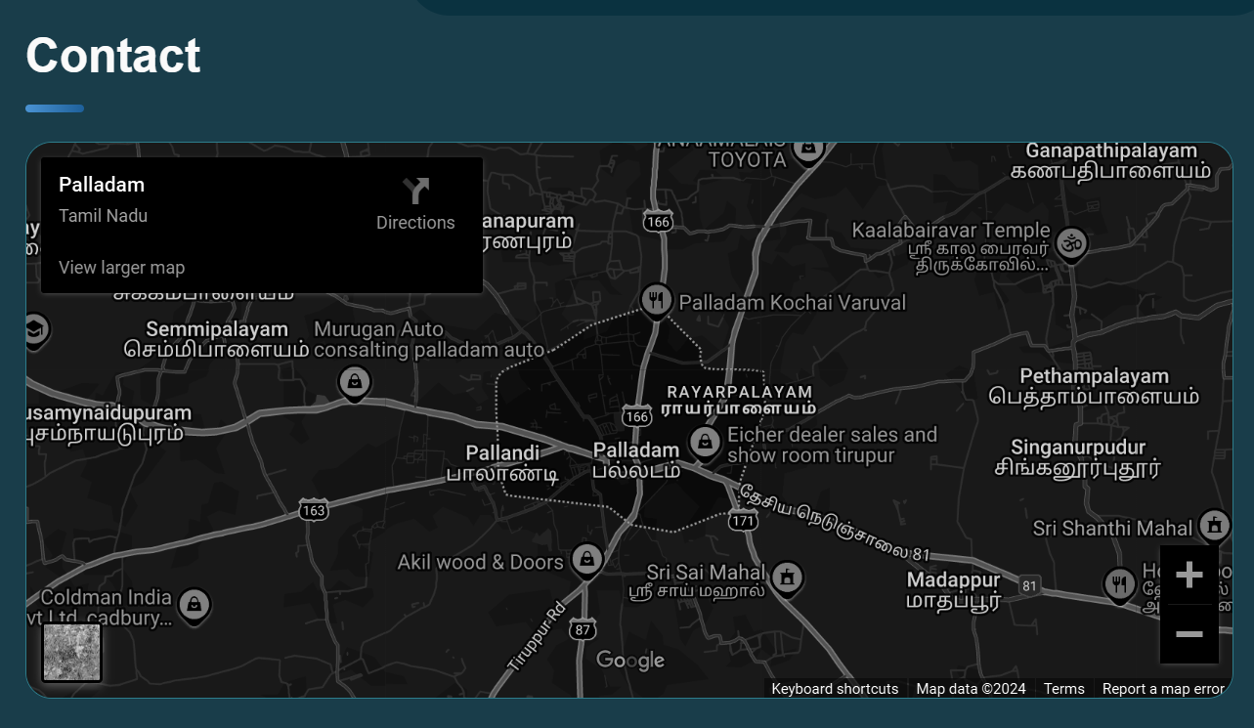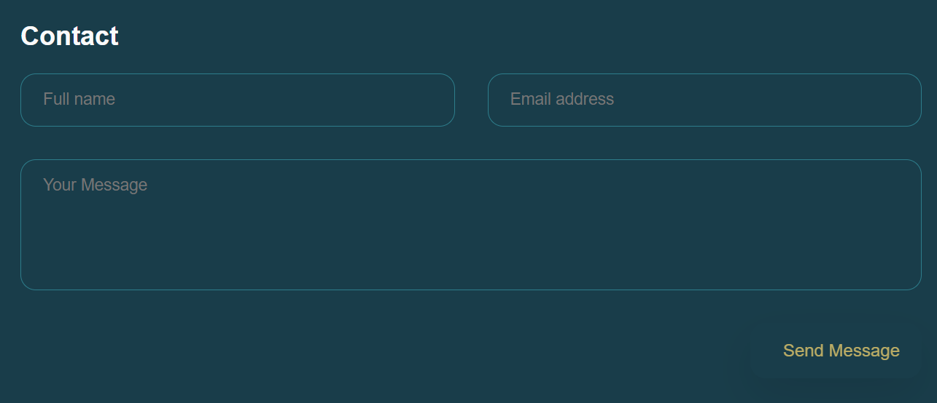

Figure- 2.3.1

**Description:**

The above displayed figure is a contact page in the website. If the user wants to contact me, they can fill the form with their valid details. Once the user filled and submitted the form page will be displayed as figure 2.3.1. This will be possible only after filled the all fields in the form. Download CV is the resume form that is the biodata of myself and details will be known explicitly.

**HTML:**

<section class="contact-form">

          <h3 class="h3 form-title">Contact</h3>

          <form action="#" class="form" data-form>

            <div class="input-wrapper">

              <input type="text" name="fullname" class="form-input" placeholder="Full name" required data-form-input>

              <input type="email" name="email" class="form-input" placeholder="Email address" required data-form-input>

            </div>

            <textarea name="message" class="form-input" placeholder="Your Message" required data-form-input></textarea>

            <button class="form-btn" type="submit" disabled data-form-btn>

              <ion-icon name="paper-plane"></ion-icon>

              <span>Send Message</span>

            </button>

          </form>

        </section>

**CSS:**

.mapbox {

  position: relative;

  height: 250px;

  width: 100%;

  border-radius: 16px;

  margin-bottom: 30px;

  border: 1px solid hsl(189, 51%, 36%);

  overflow: hidden;

}

.mapbox figure { height: 100%; }

.mapbox iframe {

  width: 100%;

  height: 100%;

  border: none;

  filter: grayscale(1) invert(1);

}

.contact-form { margin-bottom: 10px; }

.form-title { margin-bottom: 20px; }

.input-wrapper {

  display: grid;

  grid-template-columns: 1fr;

  gap: 25px;

  margin-bottom: 25px;

}

.form-input {

  color: white;

  font-size: 14px;

  padding: 13px 20px;

  border: 1px solid hsl(189, 51%, 36%);

  border-radius: 14px;

  outline: none;

}

.form-input:focus { border-color: hsl(45, 100%, 72%); }

textarea.form-input {

  min-height: 100px;

  height: 120px;

  max-height: 200px;

  resize: vertical;

  margin-bottom: 25px;

}

textarea.form-input::-webkit-resizer { display: none; }

.form-input:focus:invalid { border-color: var(--bittersweet-shimmer); }

.form-btn {

  position: relative;

  width: 100%;

  background: var(--border-gradient-onyx);

  color: hsl(45, 100%, 72%);

  display: flex;

  justify-content: center;

  align-items: center;

  gap: 10px;

  padding: 13px 20px;

  border-radius: 14px;

  font-size: 14px;

  text-transform: capitalize;

  z-index: 1;

  transition: 0.25s ease;

}

.form-btn::before {

  content: "";

  position: absolute;

  inset: 1px;

  background: var(--bg-gradient-jet);

  border-radius: inherit;

  z-index: -1;

  transition: 0.25s ease;

}

.form-btn ion-icon { font-size: 16px; }

.form-btn:hover { background: var(--bg-gradient-yellow-1); }

.form-btn:hover::before { background: var(--bg-gradient-yellow-2); }

.form-btn:disabled {

  opacity: 0.7;

  cursor: not-allowed;

}

.form-btn:disabled:hover { background: var(--border-gradient-onyx); }

.form-btn:disabled:hover::before { background: var(--bg-gradient-jet); }

**CHAPTER 3**

**PAGES & NAVIGATION**

**3.1 Landing page**

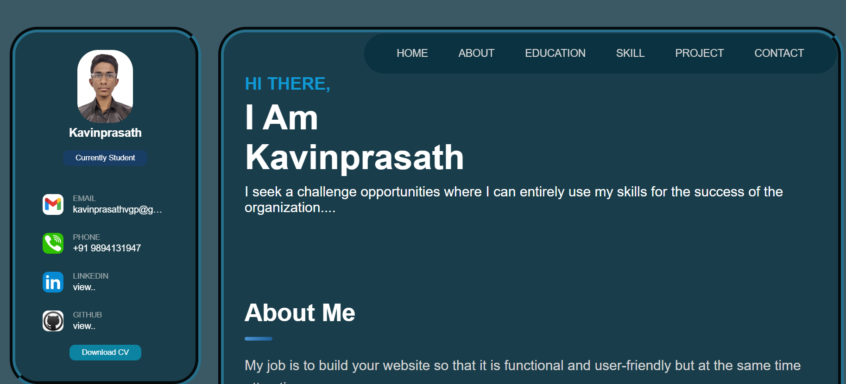

Figure- 3.1.1

## **Description:**

The above figure - 3.1.1 are the screenshot of Homepage in a desktop view. And this is a home screen of the portfolio which shows the landing page and Navigation bar. which shown as figure - 3.1.1.

}

**HTML:**

<aside class="sidebar" data-sidebar>

      <div class="sidebar-info">

        <figure class="avatar-box">

          <img src="./assets/images/kavin.jpg" style="border-radius: 30px;" alt="Kavinprasath" width="80">

        </figure>

        <div class="info-content">

          <h1 class="name" title="Kavinprasath">Kavinprasath</h1>

          <p class="title">Currently Student</p>

        </div>

        <button class="info_more-btn" style="color: white;" data-sidebar-btn>

          <span>Show Contacts</span>

          <ion-icon name="chevron-down" style="color: white;"></ion-icon>

        </button>

      </div>

      <div class="sidebar-info_more">

        <div class="separator"></div>

        <ul class="contacts-list">

          <li class="contact-item">

            <div class="icon-box">

              <!--<ion-icon name="mail-outline"></ion-icon> -->

              <img src="./assets/images/gmail icon.jpg" style="width: 30px; height: 30px; border-radius: 8px;" alt="mail">

            </div>

            <div class="contact-info">

              <p class="contact-title">Email</p>

              <a target="_blank" href="kavinprasathvgp@gmail.com" class="contact-link">kavinprasathvgp@gmail.com</a>

            </div>

          </li>

          <li class="contact-item">

            <div class="icon-box">

              <img src="./assets/images/phone icon.jpg" style="width: 30px; height: 30px; border-radius: 8px;" alt="mail">

            </div>

            <div class="contact-info">

              <p class="contact-title">Phone</p>

              <a class="contact-link">+91 9894131947</a>

            </div>

          </li>

          <li class="contact-item">

            <div class="icon-box">

              <img src="./assets/images/linkedin icon.jpg" style="width: 30px; height: 30px; border-radius: 8px;" alt="mail">

            </div>

            <div class="contact-info">

              <p class="contact-title">LinkedIN</p>

              <a target="_blank" href="https://github.com/kavin-211" class="contact-link" style="display: flex;">view..</a>

            </div>

          </li>

          <li class="contact-item">

            <div class="icon-box">

              <img src="./assets/images/github icon.jpg" style="width: 30px; height: 30px; border-radius: 8px;" alt="mail">

            </div>

            <div class="contact-info">

              <p class="contact-title" >Github</p>

              <a target="_blank" href="https://github.com/kavin-211" class="contact-link" style="display: flex;">view..</a>

            </div>

          </li>

        </ul>

        <div class="cv-content">

          <a href="https://drive.google.com/file/d/1pqNbwURco1aHtxpMgXVX-c60JzAm19jS/view?usp=sharing" class="title" target="_blank">Download CV</a>

        </div>

      </div>

    </aside>

## **CSS:**

## .sidebar,

## article {

## background: rgba(18, 55, 69, 0.826);

## border: 8px groove rgba(18, 55, 69, 0.826);

## border-radius: 40px;

## padding: 5px;

## z-index: 1;

## }

## .icon-box {

## position: relative;

## background: var(--border-gradient-onyx);

## width: 30px;

## height: 30px;

## border-radius: 8px;

## display: flex;

## justify-content: center;

## align-items: center;

## font-size: 16px;

## color: hsl(45, 100%, 72%);

## z-index: 1;

## }

## .icon-box::before {

## content: "";

## position: absolute;

## inset: 1px;

## background: var(--eerie-black-1);

## border-radius: inherit;

## z-index: -1;

## }

## .icon-box ion-icon { --ionicon-stroke-width: 35px; }

## article { display: none; }

## article.active {

## display: block;

## animation: fade 0.5s ease backwards;

## }

**3.2 Project Page**

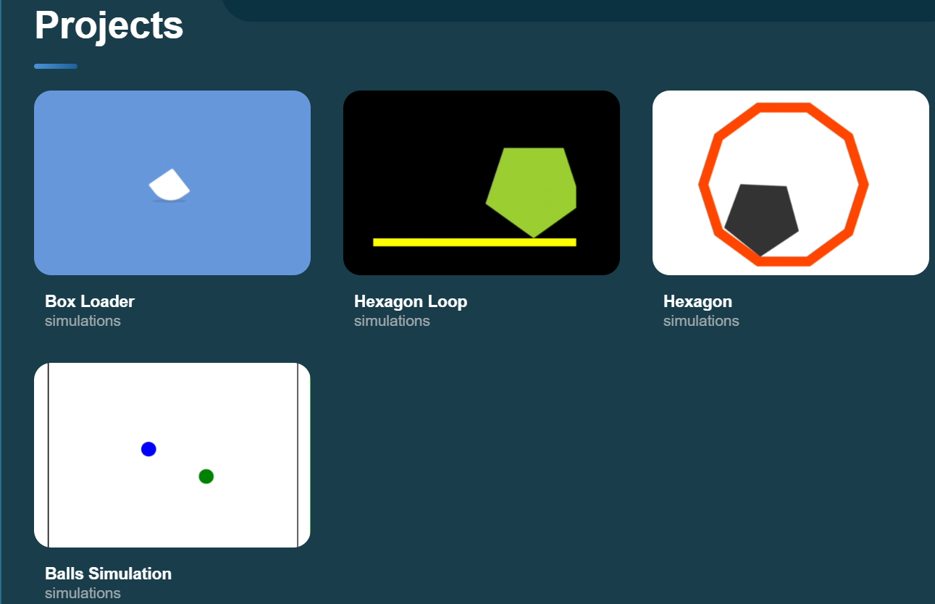

Figure- 3.2.1

**Description:**

The above figures-3.2.1 is the screenshot of project page in a desktop view. In this section, there was 4 projects. The user can easily identify the idea of the project by their index images and titles in the cards.

## **Source Code**

**HTML:**

<section class="portfolio" style="padding-top: 80px;" id="project">

        <header>

            <h2 class="h2 article-title">Projects</h2>

        </header>

        <section class="projects">

          <ul class="project-list">

            <li class="project-item  active" data-filter-item data-category="simulations" >

              <a target="_blank" href="./assets/projects/simulation/box loader.html">

                <figure class="project-img">

                  <img  src="./assets/images/projects/box loader-project.gif" alt="finance" loading="lazy">

                </figure>

                <h3 class="project-title">Box loader</h3>

                <p class="project-category">simulations</p>

              </a>

            </li>

            <li class="project-item  active" data-filter-item data-category="simulations" >

              <a target="_blank" href="./assets/projects/simulation/hexagon simulation.html">

                <figure class="project-img">

                  <img src="./assets/images/projects/hexagon loader-project.gif" alt="finance" loading="lazy">

                </figure>

                <h3 class="project-title">Hexagon loop</h3>

                <p class="project-category">simulations</p>

              </a>

            </li>

            <li class="project-item  active" data-filter-item data-category="simulations" >

              <a target="_blank" href="./assets/projects/simulation/hexagon round.html">

                <figure class="project-img">

                  <img src="./assets/images/projects/hexagon round-project.gif" alt="finance" loading="lazy">

                </figure>

                <h3 class="project-title">Hexagon</h3>

                <p class="project-category">simulations</p>

              </a>

            </li>

            <li class="project-item  active" data-filter-item data-category="simulations" >

              <a target="_blank" href="./assets/projects/simulation/ball simulation.html">

                <figure class="project-img">

                  <img src="./assets/images/projects/balls-project.gif" alt="finance" loading="lazy">

                </figure>

                <h3 class="project-title">Balls simulation</h3>

                <p class="project-category">simulations</p>

              </a>

            </li>

          </ul>

        </section>

      </section>

**CSS:**

.project-list {

  display: grid;

  grid-template-columns: 1fr;

  gap: 30px;

  margin-bottom: 10px;

}

.project-item {

  display: none;

  }

.project-item.active {

  display: block;

  animation: scaleUp 0.25s ease forwards;

}

@keyframes scaleUp {

  0% { transform: scale(0.5); }

  100% { transform: scale(1); }

}

.project-item > a { width: 100%; }

.project-img {

  position: relative;

  width: 100%;

  height: 200px;

  border-radius: 16px;

  overflow: hidden;

  margin-bottom: 15px;

}

.project-img::before {

  content: "";

  position: absolute;

  top: 0;

  left: 0;

  width: 100%;

  height: 100%;

  background: transparent;

  z-index: 1;

  transition: 0.25s ease;

}

.project-item > a:hover .project-img::before { background: hsla(0, 0%, 0%, 0.5); }

.project-item-icon-box {

  --scale: 0.8;

  background: hsl(189, 51%, 36%);

  color: hsl(45, 100%, 72%);

  position: absolute;

  top: 50%;

  left: 50%;

  transform: translate(-50%, -50%) scale(var(--scale));

  font-size: 20px;

  padding: 18px;

  border-radius: 12px;

  opacity: 0;

  z-index: 1;

  transition: 0.25s ease;

}

.project-item > a:hover .project-item-icon-box {

  --scale: 1;

  opacity: 1;

}

.project-item-icon-box ion-icon { --ionicon-stroke-width: 50px; }

.project-img img {

  width: 100%;

  height: 100%;

  object-fit: cover;

  transition: 0.25s ease;

}

.project-item > a:hover img { transform: scale(1.1); }

.project-title,

.project-category { margin-left: 10px; }

.project-title {

  color: white;

  font-size: 15px;

  text-transform: capitalize;

  line-height: 1.3;

}

.project-category {

  color: var(--light-gray-70);

  font-size: 14px;

}

**3.3 Navigation Bar**



Figure- 3.3.1

## **Description:**

The figure-3.3.1 are the samples of navigation bar in desktop View. This was a user-friendly method only, so the user can easily use the features.

**HTML:**

<nav class="navbar">

        <ul  class="navbar-list">

         <li class="navbar-item"><a class="navbar-link" href="#" >HOME</a></li>

         <li class="navbar-item"><a class="navbar-link" href="#about" >ABOUT</a></li>

         <li class="navbar-item"><a class="navbar-link" href="#education">EDUCATION</a></li>

         <li class="navbar-item"><a class="navbar-link" href="#skills">SKILL</a></li>

         <li class="navbar-item"><a class="navbar-link" href="#project">PROJECT</a></li>

         <li class="navbar-item"><a class="navbar-link" href="#contact">CONTACT</a></li>

        </ul>

      </nav>

**CSS:**

.navbar {

  width: 100%;

  border: 3px solid white;

  background-color:rgb(10, 50, 64);

  z-index: 5;

  margin-top: 10px;

  margin-right: 10px;

  position:sticky;

  top: 0px;

  transition: 5s ease;

  border-radius: 40px;

}

.navbar ul li a:hover{

  color:rgb(36, 136, 219);

}

.navbar ul li a.active{

  color: red;

}

.resume {

  color: #ffffff;

  background-color: blue;

}

.navbar-list {

  display: flex;

  flex-wrap: wrap;

  justify-content: center;

  padding: 0 10px;

}

.navbar-link {

  color: var(--light-gray);

  font-size: 15px;

  padding: 20px 7px;

  /*transition: color 0.25s ease;*/

  position: relative;

  justify-content: center;

}

**CHAPTER 4**

## **STYLES SCORE**

* 1. **Font link**

:root {

  --text-gradient-yellow: linear-gradient(

    to right,

    hsl(208, 61%, 56%),

    hsl(208, 68%, 36%)

  );

  /* solid */

  --vegas-gold: hsl(45, 54%, 58%);

  --light-gray: hsl(0, 0%, 84%);

  --light-gray-70: hsla(0, 0%, 84%, 0.7);

  --bittersweet-shimmer: hsl(0, 43%, 51%);

  /* font-family */

  --ff-poppins: 'Poppins', sans-serif;

}

/*Reset*/

*, *::before, *::after {

  margin: 0;

  padding: 0;

  box-sizing: border-box;

}

a { text-decoration: none; }

li { list-style: none; }

img, ion-icon, a, button, time, span { display: block; }

button {

  font: inherit;

  background: none;

  border: none;

  text-align: left;

  cursor: pointer;

}

## **Style links**

  <link rel="shortcut icon" href="./assets/images/logo.ico" type="image/x-icon">

  <link rel="stylesheet" href="./assets/css/style.css">

**CHAPTER 5**

## **Website include the following Information**

**5.1 project links to GitHub:**

# Project-1

Link: https://kavin-211.github.io/project1/

**Title: Box loader**

* **Project Description:**

This is Simple Implementation of the static webpage using HTML and CSS

# PROJECT 2

**Title: Random User Generation**

Link: https://kavin-211.github.io/Random-User/

* **Project Description:**

This project is a web application that generates random user information using HTML, CSS, and JavaScript. When the “Generate Random User” button is clicked, it displays a random user's name, location, phone number, email, and profile photo. The user data is fetched from a JSON file.

# PROJECT-3

# Title: Portfolio

Link: https://kavin-211.github.io/Portfolio-website/

* **Project Description:**

# Created a portfolio website using HTML, CSS, and JavaScript, It serves as a platform to introduce myself, share my projects, and provide information about my education and internship.

# CHAPTER 6

**Project README (Description, steps to run, future improvement)**

**PROJECT 1**

**Box loader simulation**

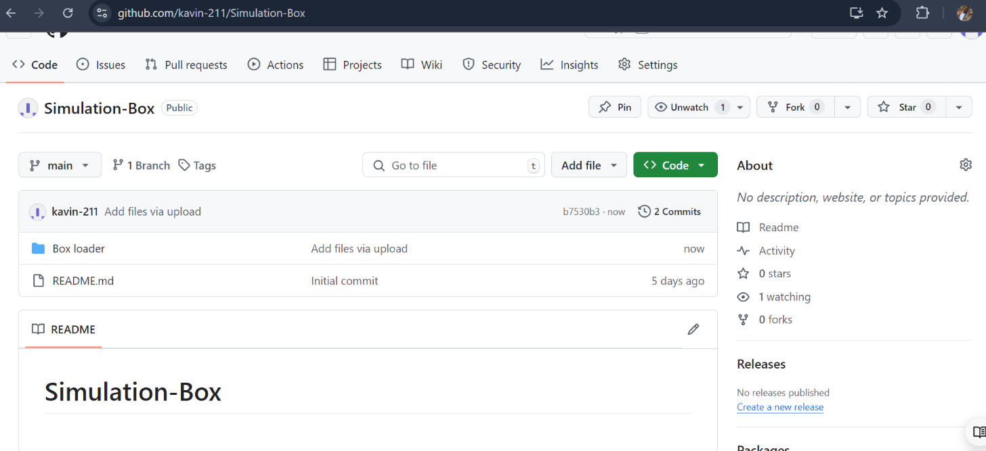

Figure 7.1.1

**Description:**

The above figures 7.1.1 is the screenshots of project README files (Description, steps to run, future improvement) in a desktop view.

**Chapter-7 File structure**

**7.1 GitHub file structure**

**Task- 1 file structure:**

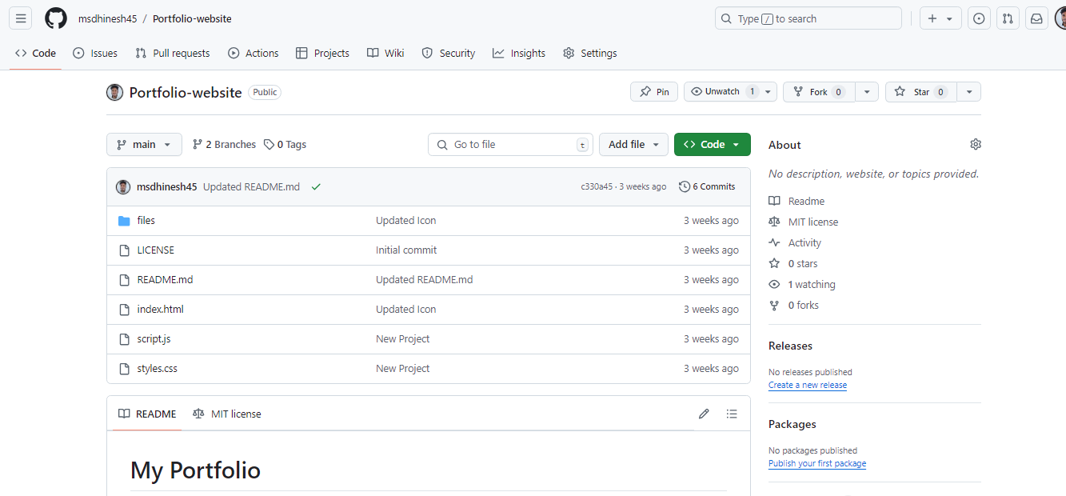

Figure 7.1.1

## **Description:**

The above figures 7.1.1 are the screenshots of project GitHub file structure in desktop view.